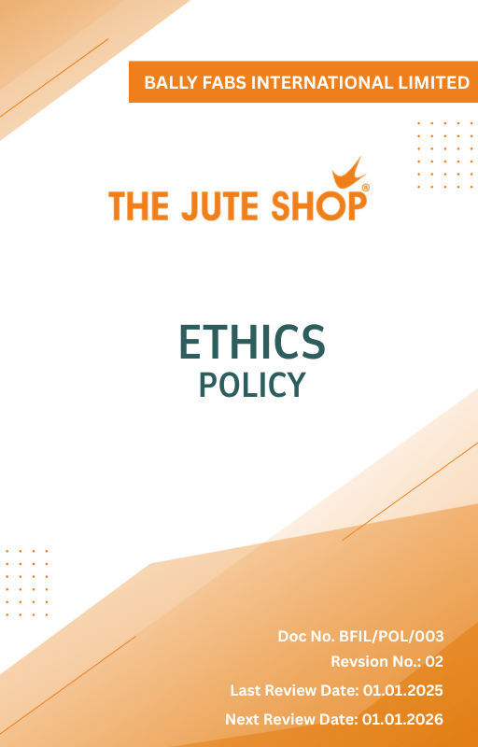

Contents

Introduction 3
Policy Statement 3
Scope 3
Key Focus Areas 3
Qualitative Objectives 4
Quantitative Targets 5
Alignment with the United Nations SDGs 6
Examples and Guidance 7
Continuous Improvement 8
Addressing Policy Violations 9
Responsibilities 9
Review Mechanism 10
Revision History 11
Employee Acknowledgment Form 12

Introduction
Ballyfabs International Limited is committed to upholding the highest standards of ethical conduct in every aspect of its operations. We believe that integrity, accountability, and transparency form the foundation of a sustainable and trustworthy business. This policy reflects our dedication to preventing corruption, eliminating unethical practices, and safeguarding information security across all functions of the organization.

Policy Statement
Our company is dedicated to preventing any form of corruption and ensuring the secure handling of information. This policy sets forth our commitments and quantitative targets for achieving these goals.

Scope
This policy applies to all workers, employees, directors, officers, agents, contractors, and any third parties acting on behalf of Ballyfabs Int. Ltd. (BFIL). It covers all business activities, including procurement, sales, marketing, and any interactions with government officials, customers, suppliers, and other stakeholders. The policy is applicable globally, regardless of local business practices or cultural norms. This policy applies to the below-mentioned locations:

Site | Address
Bally Fabs International Limited | - 3, Haren Mukherjee Road, Belur, Howrah-711202, West Bengal, India.
Bally Fabs International Limited | - Vill-gangarampur, PO-Dakshin Alipore, ps-Bishnupur, Dist-South 24 Parganas, Pin-743503, West Bengal, India

Key Focus Areas
- Corruption Prevention: Prevent offering, promising, giving, accepting, or soliciting an advantage as an inducement for any action that is illegal, unethical, or a breach of trust.
- Information Security: Ensure secure collection, processing, and storage of third-party information.
- Conflict of Interest: Require disclosure and proper handling of personal or professional interests that may influence company decisions.
- Fraud: Prevent and detect fraud through internal controls, regular audits, and secure reporting mechanisms.
- Anti-Money Laundering: Comply with AML laws by verifying transactions, monitoring for suspicious activity, and training employees on red flags.
- Responsible Use of Company Assets: Use company resources efficiently and solely for legitimate business purposes, avoiding waste or misuse.

Qualitative Objectives
- Corruption Prevention
- Carry out due diligence specific to anti-bribery and corruption when evaluating mergers and acquisitions and joint ventures
- Maintain a zero-tolerance policy for bribery and corruption and ensure strict compliance with anti-corruption laws and company policies.
- Promote a culture of integrity where employees understand the importance of rejecting bribery and unethical practices.

- Information Security
- Enforce and maintain stringent information security protocols to protect sensitive business, employee, and client data from unauthorized access, breaches, and cyber threats.
- Ensure continuous improvement of security measures in line with emerging threats and regulatory requirements.

- Conflict of Interest
- Promote a culture of transparency, encouraging employees to avoid situations where personal interests could conflict with business interests.
- Ensure implementation of clear procedures for handling potential conflicts of interest fairly and impartially.
- Ensure that company decisions are fair, impartial, and free from personal or financial bias.
- Maintain transparency in dealings with suppliers, clients, and partners by documenting and managing conflicts appropriately.

- Fraud
- Strengthen organizational trust by establishing a zero-tolerance approach to fraudulent behavior.
- Encourage vigilance and accountability among employees in detecting unusual or suspicious activities.

- Anti-Money Laundering (AML)
- Promote awareness of AML among employees, emphasizing vigilance in transactions.
- Ensure adherence to legal and regulatory requirements to prevent misuse of company operations for illegal purposes.
- Build a culture of ethical compliance where all suspicious activity is reported and addressed promptly.

- Responsible Use of Company Assets
- Promote efficient and ethical use of company resources through awareness campaigns.
- Implement clear guidelines for personal use of company assets to avoid conflicts.

Quantitative Targets
The year 2023 serves as the baseline for all ethical governance targets at Bally Fabs , including those related to business integrity, anti-corruption, conflict of interest, fraud prevention, and anti-money laundering. Progress will be measured against this baseline to ensure continuous improvement through years with the targets set for year 2030.

- Corruption Prevention
- Ensure inclusion and compliance of anti-bribery clauses into 100% of supplier and partner contracts by year 2030.
- Train 100% of procurement and finance teams on anti-corruption policies annually.
- Maintain zero instances of corruption reported in annual audits.

- Information Security
- 100% of employees complete information security awareness training by year 2030, covering data privacy, phishing prevention, and risk mitigation strategies.
- Maintain zero incidents of unauthorized data access and breaches through improved controls by year 2030.

- Conflict of Interest
- Achieve 100% completion rate of conflict of interest disclosures by all managers by year 2030.
- Ensure 100% of new hires complete conflict of interest orientation within the first month of joining.

- Fraud
- To maintain the implementation of a fraud detection mechanism to monitor and flag suspicious activities, and hence achieve 0% of undetected fraudulent transactions by year 2030.
- Conduct fraud risk assessments across all functions annually.
- Maintain zero fraud - related incidents annually.

- Anti-Money Laundering (AML)
- 100% of relevant employees complete AML training by year 2030.
- Zero non-compliance incidents with AML regulations till year 2030.

- Responsible Use of Company Assets
- Conduct quarterly asset usage reviews to ensure 100% resources are used only for business purposes.
- Maintain 100% compliance with asset usage policies by year 2030.

Alignment with the United Nations SDGs
The sustainability objectives and performance targets align with the following Sustainable Development Goals (SDGs):
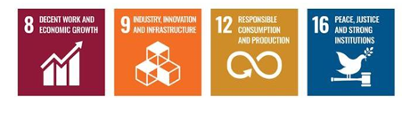

Examples and Guidance
To support consistent understanding and implementation of this Ethics Policy, the following topic-wise examples and guidance offer practical interpretations of expectations and actions:

- Preventing Corruption
- Example: A supplier offers a procurement executive luxury event tickets in return for favorable contract terms.
- Guidance: The executive must decline the offer and report it to the compliance officer. Accepting such gifts violates anti-corruption policies. Employees must maintain objectivity and transparency in all supplier dealings.
- Conflict of Interest
- Example: A project manager is asked to evaluate a vendor owned by their spouse.
- Guidance: The manager must disclose the relationship and recuse themselves from the selection process. All potential conflicts must be reported, and decisions must be made without personal bias or undue influence.
- Fraud
- Example: A finance team member notices duplicate invoices submitted by a vendor for payment.
- Guidance: The incident should be flagged and investigated immediately. Employees should report any financial irregularities through proper channels and ensure transactions are thoroughly reviewed.
- Anti-Money Laundering
- Example: A customer asks to divide a large transaction into smaller amounts to avoid reporting thresholds.
- Guidance: This is a red flag for potential money laundering. The transaction must be reported and flagged for review as per AML protocols. Employees must be trained to recognize and respond to suspicious financial behavior.
- Information Security
- Example: An employee accidentally leaves printed confidential client information in a public area.
- Guidance: The breach must be reported to IT and compliance immediately. Sensitive data must be securely stored and disposed of. Employees should follow data protection protocols at all times.

Continuous Improvement
At Bally Fabs International Ltd., Ethical Conduct practices are continuously enhanced to stay aligned with evolving regulations, industry standards, and emerging risks. A strong culture of integrity is embedded across all levels of the organization, ensuring transparency, accountability, and regulatory compliance.

- Ongoing Training & Awareness: Employees undergo annual training on key ethical topics, including anti-corruption, conflict of interest, fraud prevention, anti-money laundering (AML), and information security.
- Risk Assessments & Independent Audits: Regular internal reviews and third-party audits help identify potential ethical risks, evaluate policy effectiveness, and drive corrective actions.
- Collaborative Compliance Engagement: Active participation in industry forums and regulatory dialogues supports alignment with best practices and ethical norms.
- Advanced Monitoring & Reporting Systems: Secure digital tools and automated monitoring mechanisms strengthen fraud detection, compliance management, and incident reporting.
- Feedback & Transparency Culture: Open channels for feedback empower employees and stakeholders to share concerns or suggestions, driving continual ethical improvements.

Addressing Policy Violations
Bally Fabs International Ltd. maintains a zero-tolerance approach toward violations of its Ethics Policy. All suspected or confirmed breaches will be handled seriously, fairly, and in a timely manner to uphold the company’s values of integrity, transparency, and accountability.
- Reporting Violations: Employees are strongly encouraged to report any unethical or suspicious behaviour through appropriate channels, including direct supervisors, the internal compliance team, or the company’s confidential whistleblower system, which allows anonymous submissions without fear of retaliation.
- Investigation Process: All reported concerns will be promptly investigated by designated personnel or third-party experts, ensuring impartiality and strict confidentiality throughout the process. The identity of whistleblowers will be protected unless disclosure is legally required.
- Corrective Actions: When a violation is confirmed, the company will take appropriate disciplinary action based on the severity of the offense. This may include formal warnings, mandatory retraining, suspension, reassignment, or termination of employment. For example, an employee found accepting unauthorized payments from vendors may face immediate dismissal and legal prosecution.
- Protection from Retaliation: Retaliation in any form against whistleblowers or those cooperating with an investigation is strictly prohibited. Any individual found engaging in retaliatory behaviour will be subject to disciplinary consequences.

Responsibilities
At Bally Fabs International Ltd., upholding ethical conduct is a collective responsibility:
- Compliance Officer: Ensures implementation of ethical policies and compliance with anti-corruption, conflict of interest, fraud, and information security standards.
- HR Manager: Oversees employee training on ethical conduct, including anti-corruption and conflict-of-interest policies.
- IT Manager: Safeguards company and customer data through secure information systems.
- Internal Audit Team: Conducts audits to assess policy compliance and identify risks.
- Senior Management: Reviews ethical performance, allocates resources, and promotes a culture of integrity.

Review Mechanism
The Ethics Policy is reviewed annually by the Compliance Officer to ensure its continued relevance, effectiveness, and alignment with legal and regulatory requirements. Updates may be made based on audit findings, changes in applicable laws, employee feedback, or evolving business practices. Any revisions are communicated to all employees, and necessary training is provided to ensure awareness and compliance.

Revision History
Amendment of Revision No. | Effective Date | Details of Amendment of Revision
01 | 01.01.2024 | Scope
01 | 01.01.2024 | Key Focus Areas
01 | 01.01.2024 | Review Mechanism
02 | 01.01.2025 | Key Focus Areas
02 | 01.01.2025 | Qualitative Objectives
02 | 01.01.2025 | Quantitative Targets & Target Year
02 | 01.01.2025 | Responsibilities
02 | 01.01.2025 | Alignment with the United Nations SDGs
02 | 01.01.2025 | Examples and Guidance
02 | 01.01.2025 | Continuous Improvement
02 | 01.01.2025 | Addressing Policy Violations

Effective Date | : 01.01.2025
Next Review Date | : 01.01.2026
Revision No. | : 02

Approved By :

Employee Acknowledgment Form
I, acknowledge that I have read, understood, and agree to adhere to the company’s Ethics Policy. I recognize the importance of my role in supporting the company’s commitment to ethical behavior and commit to actively participating in its implementation.
I will strive to incorporate ethically responsible practices into my daily work, comply with all relevant ethics regulations and company policies, and support continuous improvement of ethical performance.
I understand that my commitment is essential to achieving the company’s ethics objectives and fostering a culture of integrity and responsibility. I am dedicated to contributing to our shared vision of a trustworthy and ethical workplace and demonstrating our dedication to ethical stewardship.

Employee Name | : _________________________
Employee ID | : _________________________
Department | : _________________________
Signature | : _________________________

